NATURAL HISTORY OF CLEVELAND PAPER
Student’s Name
Class Name
Class Number
Institution
Date

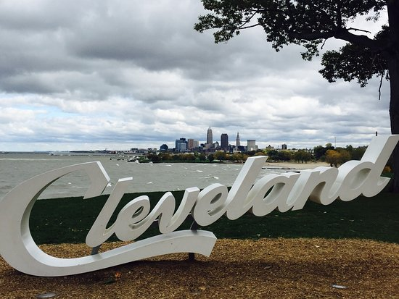
Introduction
Parks are areas either natural or semi-natural put aside for human enjoyment purposes, recreation, wildlife or natural habitat protection. The parks are comprised of trees, rocks, grass soil, buildings or artifacts such as fountains, monuments, statues or playing grounds. The parks are strategically designed to bring people together while ensuring their safety (Ikin et. al, 2013). Northeast Ohio is one beautiful land full of different amazing attraction sites including parks which gives this city its own uniqueness. Below is a discussion of five different parks located in located in Northeast Ohio, from the Lake Erie Islands east to Ashtabula.
Bow Wow Beach
Bow Wow Beach is a special use park located in Summit County. The beach covers 7.5 acres of land that is surrounded by a three acres lake where dogs enjoy swimming. The park was opened in 2007 and since then many people have visited and enjoyed the good services offered in this park. The park is composed of both the beach area and the grassy areas. Additionally, there are sunny spots and shades and a small dog are used for wee pooching. The beach is well maintained and is safe. The park has several gates that prevent dog escapes as well as preventing entry of dogs with no owners. At the entrance are a large basin and a hose used to clean up dogs after hours of rolling on the ground. The place offers an exciting and uplifting experience and due to its large size one never feels overcrowded even during their peaks days such as Saturday's. There is enough room for everyone (Bow Wow Beach Dog Park, 2017).
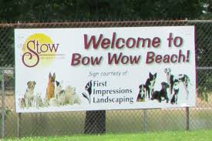 Fig.1. Bow Wow Beach Dog Park Stow Ohio.
Sunny Lake
The Sunny Lake Park is a community park stretched in a 1.8-mile loop trail. The park has a lake and is located near Aurora in Ohio. This feature is mainly used for walking and hiking and is accessible during all seasons of the year. The trail is also used by dogs which must be guided using a leash. I loved and enjoyed this spot during my visit to Aurora. I enjoyed getting outside with my friends to enjoy each other’s company. I found the lake fascinating and peaceful with many ducks, some cranes, and geese. As you walk along the trail there are benches where you can just sit and enjoy the view of the lake. In the park are peddle boats and fishing docks which one can rent. This place is awesome and I would recommend any person who would want to go out for walks or runs for fun. The park has a variety to offer to the community given its many sports amenities such as the baseball and volleyball playing grounds (Sunny Lake Park, 2017).
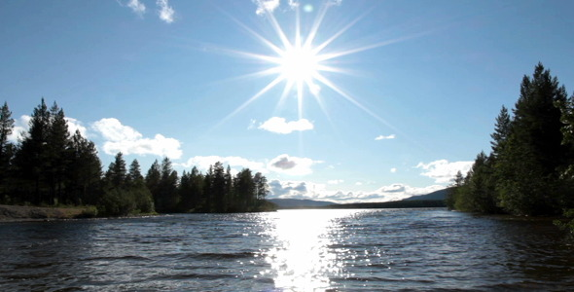 Fig.2. Sunny Lake by rover5.
Edgewater Park
Edgewater Park is a 147 acres park and is the westernmost park in Cleveland Metro parks Lakefront Reservation. The park 9000 shoreline feet, fishing pier, picnic areas, grills, dog and swimming beaches, boat ramps and pavilion for renting. A 240 acres land that includes the park beach, Marina, Perkins Beach and Yacht Club also allows a lot of family-oriented activities to take place. Although features such as clubs and boats are not freely available to the public, a few boat ramps are provided for use. The features and the activities undertaken in this place bring the community together and as such the park is a community type of park (Edgewater Park, 2017).
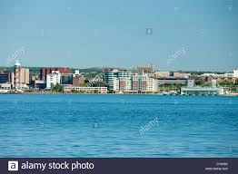 Fig.3. Edgewater Cleveland scene.
South Chagrin Falls Reservation
South Chagrin Falls reservation is situated along the Chagrin River. The park is a large urban park and a part of the reservation, Bentleyville, is located in Bainbridge. Most people visit this area to the beautiful waterfalls in Quarry Rock and several swimming areas where people ride their inflatables along the shallow parts of the river. The trail and the amazing view of Chagrin River and the small waterfalls are always accessible all year round. This is a community park. The natural waterfalls and the river are not artificial and it has been there for a long time. In the park is the sculpture of the famous Henry Church. The park also offers horse riding sessions all of which help bring the community together (South Chagrin Reservation, 2017).
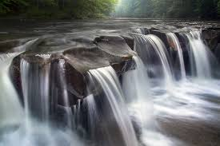 Fig. 4. Chagrin River in Bentleyville
Wendy Park
The whiskey island in Cleveland holds the Wendy Park. Wendy Park has many features and amenities that serve the community and thus, it is a community park. The park occupies a 22 acres land in Ohio. The downtown part of Cleveland is where the park is sited. The uniqueness of the park is seen through its ability to sustain 260 different species of birds something that has made it the top bird site in Ohio. During my adventure in this park, I enjoyed many activities such as paddle sporting, boat riding, volleyball playing and fishing and playing volleyball (Cleveland Metroparks, 2018).
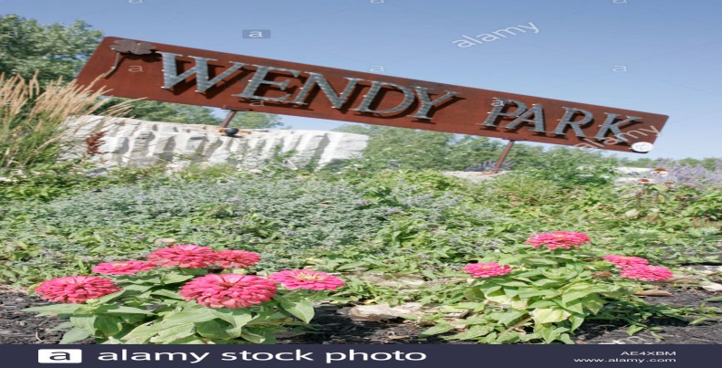Fig.5. Cleveland Ohio Lake Wendy sign.
Conclusion
Each of the above parks is unique in its own ways. The uniqueness of each park is defined by their sizes, locations features that differ in each instance and their special purposes. Nonetheless, all serve the same purpose of providing the best for the community surrounding them.

References
Bow Wow Beach Dog Park. (2017). Retrieved from; http://stowohio.org/bow-wow-beach-dog-park/
Cleveland Metroparks. (2018). Wendy Park. Retrieved from; https://www.clevelandmetroparks.com/parks/visit/parks/lakefront-reservation/wendy-park
Edgewater Park. (2017). Retrieved from; https://www.clevelandmetroparks.com/parks/visit/parks/lakefront-reservation/edgewater-park
Ikin, K., Beaty, R. M., Lindenmayer, D. B., Knight, E., Fischer, J., & Manning, A. D. (2013). Pocket parks in a compact city: how do birds respond to increasing residential density?. Landscape ecology, 28(1), 45-56.
South Chagrin Reservation. (2017). Retrieved from; https://clevelandmetroparks.com/parks/visit/parks/south-chagrin-reservation
Sunny Lake Park. (2017). Retrieved from; http://www.auroraoh.com/599/Sunny-Lake-Park

